# Exercise 7: Financial Forecasting

***Recursion Concept***

Recursion is a programming technique where a method calls itself to solve smaller instances of the same problem. It simplifies problems that can be broken down into identical subproblems.

Simplifies code for problems with recursive nature (e.g., tree traversals, mathematical sequences)

It contains Base case (simplest instance that can be solved directly) and Recursive case(method calls itself with a modified input to progress toward the base case).

FinancialForecaster.java:

package com.example;

public class FinancialForecaster {

public static double calculateFutureValue(double currValue, double growthRate, int periods) {

if(periods == 0) {

return currValue;

}

double nextValue = currValue * (1 + growthRate);

return *calculateFutureValue*(nextValue, growthRate, periods - 1);

}

}

Main.java:

package com.example;

public class Main {

public static void main(String[] args) {

double initialInvestment = 1000.0;

double annualGrowthRate = 0.07;

int years = 10;

double futureValue = FinancialForecaster.*calculateFutureValue*(initialInvestment, annualGrowthRate, years);

System.***out***.printf("Initial investment: $%.2f%n", initialInvestment);

System.***out***.printf("Growth rate: %.2f%%%n", annualGrowthRate * 100);

System.***out***.printf("Years: %d%n", years);

System.***out***.printf("Future value: $%.2f%n", futureValue); }

}

Output:

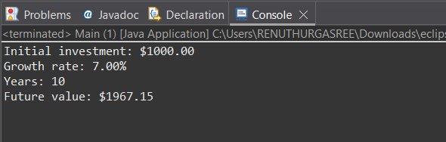

***Analysis:***

*Time complexity:*

Each recursive call reduces periods by 1 until reaching 0. If there are n function calls for n periods then time complexity is O(n).

*Space complexity: O(n)*

*Optimization techniques:*

* Memorization : stores previously computed results to avoid redundant calculations. Useful when the same parameters are used repeatedly.
* Iterative approach: it reduces space complexity to O(1). Avoids potential stack overflow for large periods.
* Mathematical formula : it reduces both time and space complexity to O(1). Most efficient but less flexible.